**Writer: Ashrafi Bhagat**

**CHOLAMANDAL ARTISTS’ VILLAGE**

The Cholamandal Artists’ Village is the artists’ residential cum cultural centre situated in Injambakkam at Chennai, Tamilnadu, South India established by the artist K.C.S. Paniker [1911-1975] along with a group of artists in April 1966 on 8.4 acres of land. The main aim in establishing this centre in the 1960s was to offer the opportunity of practicing art as a profession after graduation. This was a major concern that led Paniker to think about providing studio facilities or a commune where the artists would have work space, opportunities for interaction and creative experimentation, while simultaneously generating a parallel income by creating artistic craft objects that would be sold through the Artists Handicrafts Association, which he founded in 1963. Among the first group of artists who moved into the village in May 1966 were K. Jayapal Panniker, V. Viswanathan, K.R. Harie, K.M. Adimoolam, C. Dakshinamoorthy, K. Ramanujam A.C. Mamman to live and work in trying and hazardous conditions. Others who settled here later included S.G. Vasudev, Paramasivam, P.S. Nandhan, K.V. Haridasan, and C. Douglas. Cholamandal also saw two women artists purchasing land with an avowed idea of marking their presence within a male dominant community. They were Anila Jacob, sculptor, and Arnawaz Driver.

Today a museum has been established , on the site, named after its founder - K.C.S. Paniker Museum of Madras Movement - with a holding of representative works of those seminal artists who contributed in the making of the Madras Art Movement. A commercial gallery called Indigo and Labernum offers space for exhibitions.

The Cholamadal Artists’ Village was a vision of K.C.S. Paniker where artists would live together as a commune to foster the spirit of artistic brotherhood, collective organization, exchanges of creative ideas and a resultant harmony as they worked on their creative projects. It was founded with the main aim of providing studio space for young graduating artists to practice the profession of painting and other related arts. This was a dire need which Paniker fulfilled largely by buying 8.4 acres of land through the sale of crafts objects created by the students and faculty of the Government College of Arts and Crafts. These craft objects were sold through various government agencies such as the Handicrafts Board, the State Art Emporium and the Victoria Technical Institute, with the latter also processing their foreign orders.

The period of the early 1960s was a trying one for the Madras artists. Patronage was rare accompanied by a lack of contemporary visual art awareness among the public in a city that was a stronghold of performing arts namely dance and music. Unlike Bombay and Delhi where the European war émigrés peddled the cause of modernism in local newspapers, in Madras, a conservative daily like ‘The Hindu’ could not offer meaningful support and ‘The Mail’ patronized the decorative crafts. Within such a milieu it was difficult for the artists to survive on their artistic practice and supplementary income needed to be found. Many who graduated from the art institution were absorbed as art teachers in schools, designers in the Weavers Service Center, or as finishing artists in commercial art establishments.

To buy the land to set up the residential work-center for the artists that would fundamentally operate on a co-operative basis, the sale of artistic craft objects created a corpus, which materialized Paniker’s idea for the village to be formally established in February 1964, becoming a reality on 13th April, 1966. The land was allotted to forty seven members. On the Corommondal coast, six miles south of Madras, on 8.05 acres of land Paniker’s brainchild– The Cholamandal Artist Villagecame into existence. The name reinforced Paniker’s ideology of being Indian in spirit by a conscious link with past heritage and hence a continuity of tradition. The name Cholamandal provided connectivity to the historical dynasty of Cholas that ruled along the Eastern coast, as well to the artistic tradition of the Pallavas situated few miles from the artists’ village at Mamallapuram.

With the birth of the concept of an artists’ village, Paniker opened opportunities for artists to continue with their creative projects. Els Van Der Pas a Dutch curator who visited the artists village in 1989 observed, “In this village the artists were free and bound, timeless and traditional, individual and universal as intellectually and artistically they waged the struggle between the east and the west, Asian forms and European freedom in igniting the spark of modern and Indian in this fertile paradox called ‘Cholamandal artists’ village’.”

Paniker the ideologue had manifested his vision and his students and colleagues provided support in his endeavours. S.G. Vasudev, a seminal artist of the Madras art Movement and the then Secretary of the Artists’ Handicrafts Association said, “Cholamandal is perhaps the first of its kind anywhere in the world, a vision of fulfillment, a place where the artists meet society as an integral part of it”. He also, forcefully reiterated “there is no ideology or art style to which an artist must conform. The two basic freedoms so vital to an artist – freedom of expression and freedom from the shackles of earning a livelihood – are provided here. This left the artists free to create as he wished”. In this respect Cholamandal became a unique symbol of cooperative enterprise and community living operating without government support.

The Artists’ village was not only the locus of painterly and sculptural creative activities, but also a place where the allied arts of dance, drama, theatre, music, poetry readings and active discussions on art were also vigorously practiced.

The village space served international visitors who came from different parts of the world and left behind a slice of their memorable sojourn. A Dutch artist built a potters’ wheel and a New Zealand artist thoughtfully put together a badly-needed kiln for the village. American printmakers, especially Paul Lingren, introduced a range of new techniques and the West German Government in an admirable display of community feeling, donated the cost of a two- apartment guesthouse to the village. The symbiosis occurred between a domestic and an international fraternity that soon brought Cholamandal Artists’ Village onto the international map. Acceptance and recognition came from diverse quarters when artists from the village were invited to participate in the Venice Biennale, the Paris Biennale, the Sao Paolo Biennale and the Commonwealth Art Festival in London.

The concept of an artists’ commune, Cholamandal was envisaged as a place instrumental in offering a creative alternative to many young talents that otherwise would have been lost in the banality of proletarian existence.

### CHOLAMANDAL TODAY

Cholamandal today has progressively marched with the times and has also developed into an important tourist site. It regularly organizes exhibitions, publicizing the artistic character of the village via books, websites, tourist brochures, calendars and postcards. Since tourism has come to shape the twentieth century, the village has changed from artists’ habitat and work center to a tourist destination that combines art and commerce. The art shop provides sales of paintings, sculptures and crafts, particularly metal work produced by the artists creating a hybrid form of tourism, popular with the educated middle classes.

In February 2009, a Contemporary Cultural Centre comprising 10,000 sq ft of space, which includes K.C.S. Paniker Museum of Madras Movement to represent the artists of the Madras art Movement and two commercial art galleries namely Indigo and Labernum was inaugurated.

The Village has taken on different hues and texture. As the first generation of artists have tasted success and national fame, their children are emerging; whose artistic practices reflect global trends and have moved beyond traditional inspiration in the Post Madras Art milieu.

References and further reading:

Bhagat, Ashrafi, ‘A critical Study of Modernity in South India with particular reference to the Madras School: 1960s and 70s’, unpublished Ph.D. thesis, Department of Aesthetics and Art History, faculty of Fine Arts, M.S. University, Baroda, 2005.

De, Aditi, (1986)‘Cholamandal Two Decades’, in Two Decades of Cholamandal Artist Village. [Madras:

sponsored by Lalit Kala Akademi, New Delhi and Tamil Nadu Oviam Nunkalai Kuzhu, 1986].

James Josef [ed.] “Cholamandal: An Artists’ Village”, [Chennai, O.U.P., 2004, pg. 79.]

Suni,l K.P., (1991), ‘The village by the sea’, The Illustrated Weekly of India, Weekend 12th-15th January

1991.

Images

As to copyright all these images were given to the author by an artist in Cholamandal village who is an office bearer of the Artists Handicrafts Association, with permission to publish.

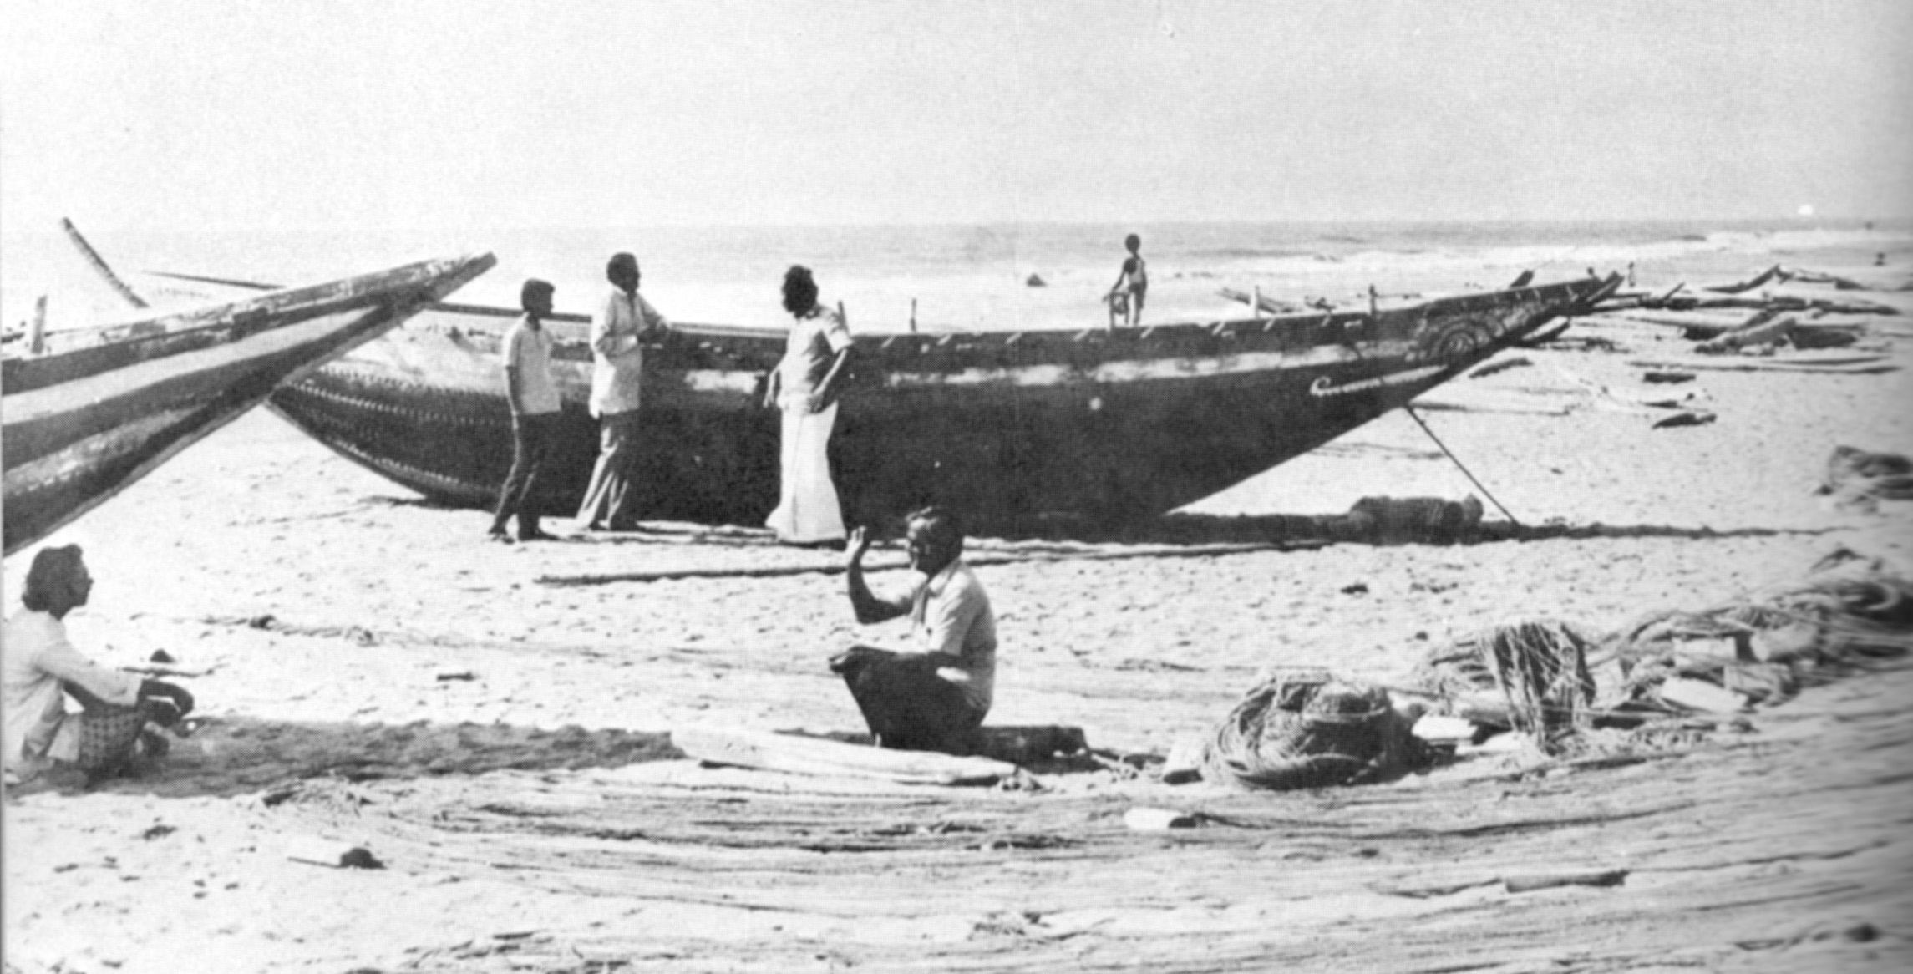

Artists from Cholamandal artists’ village on the nearby beach

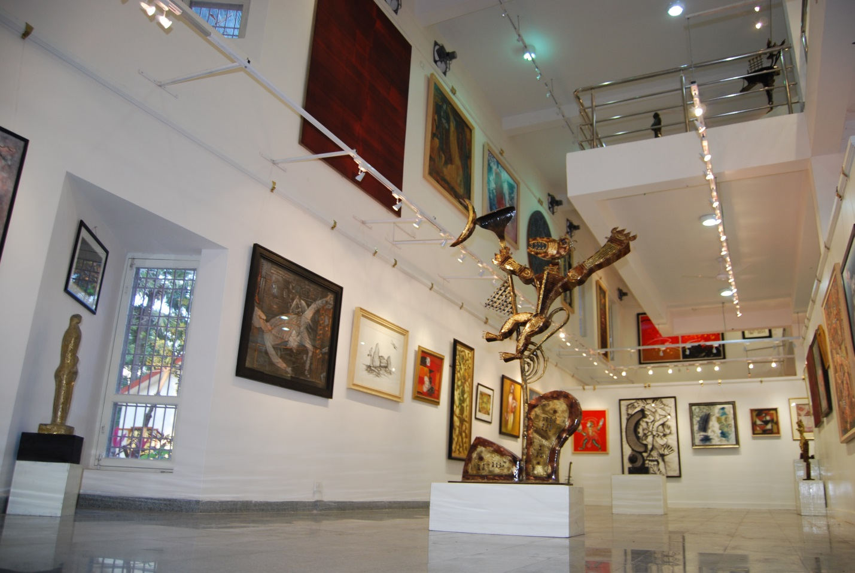

Art shop below the K.C.S. Paniker Museum

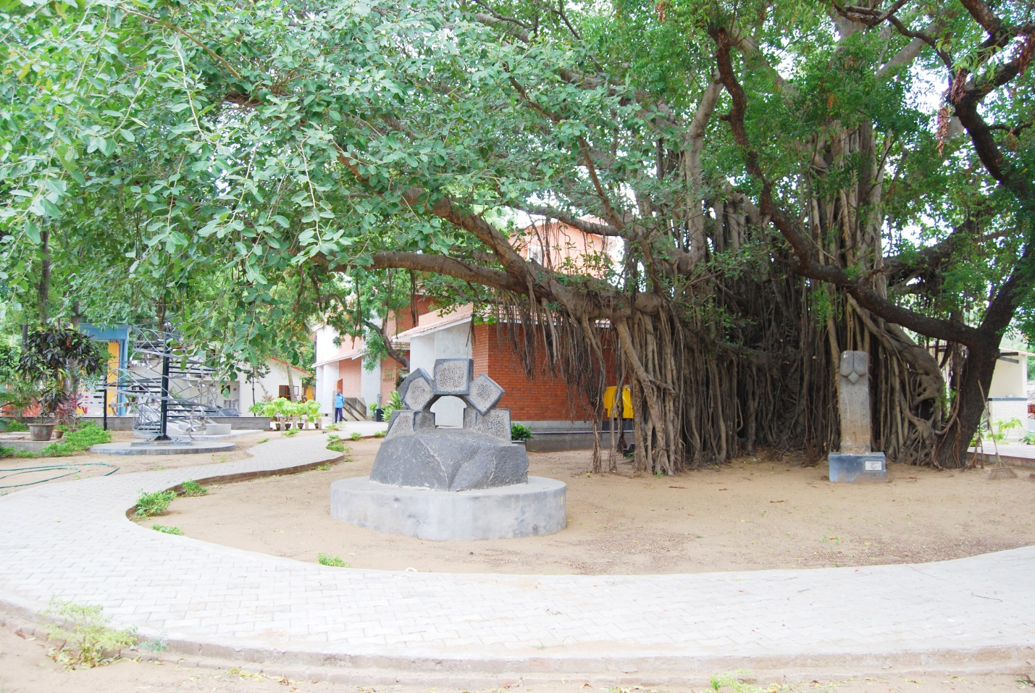

The K.C.S Paniker Museum of the Madras Art Movement with open air sculpture under the banyan tree